- Is Registration open for Spring 2024?
Yes, simply log into your account and register your player(s):

deerfieldbeachlittleleague.com

- What is the price and ages for each Division?
Below are the prices and ages for each division:
Division | Ages | Price
TBall | 3 to 6 | $50
Coach Pitch | 6 to 8 | $175
Minors (Kids Pitch) | 9 to 12
Majors (Kids Pitch Advanced Level) | 10 to 12
50/70 (Advanced Level) | 11 to 13
Juniors | 13 to 14
Seniors | 15 to 16 | $100

Please remember to use the 2024 Little League Age Chart to determine to players “League Age” for registration. Still not sure which division to select? It’s ok, use your best judgement. All players in divisions Coach Pitch and up will be evaluated and placed in the most appropriate division prior to the draft by the BoD.
- What are the address’ for the home fields?
Deerfield Middle School Athletic Complex
501 SE 6th Ave
Deerfield Beach, FL 33441

Pioneer Park
217 NE 5th Ave
Deerfield Beach, FL 33432
The older divisions do interleague with Fort Lauderdale Little League, Northeast Little League, Coral Springs Little League, Coconut Creek Little League, North Springs Little League and Parkland Little League. Teams will travel to those home fields and address’ will be provided by coaches. It’s so much fun!

- What is the last day to register?

The last day to register for Spring is 1/27. We must give the uniform company our order one month in advanced to ensure we have the uniforms in time for Opening Day which is tentatively scheduled for 3/4. Players that register after this date will be placed on a waitlist and we cannot guarantee they will have a uniform in time for their first game.

- It’s my players first time, what if they don’t like it?

We encourage all players to sign up and give it a chance no matter what age. Everyone starts somewhere and development is the heart of our league. If they give it a try and don’t like it, it’s no problem. We will provide a refund if notified within the first 30 days minus the uniform cost. This rarely happens though!

- What days are games and practices?

Tee Ball will have practices on Wednesdays and Games Saturdays. We will not know the schedule for the older divisions until registration closes and teams have been formed. The schedule depends on how many teams we have in each division. If the schedule doesn’t work for your player, you can always request a refund within the first 30 days (minus the uniform cost). We understand you need to know ASAP as many of our players and families have other commitments. We will release the schedule as soon as possible and appreciate your understanding.

- How long does the season run?

The regular season will run from January until May. Allstars runs June through July.

- I’m interested in volunteering; do you need help?
YES!!!! Our league is seriously lacking parent involvement, and the existing volunteers are burnt out. We need you! No job is too small. We have duties from score keeper for games all the way up to Board Members. Want your voice to be heard then join the Board! Remember we are all volunteers who work with full time jobs. We are busy just like you
- I want to Coach but I have no baseball experience, do you want me?
YES! Again, development is the heart of our league and that goes for coaches too. In fact, it’s easier to start at the lower level. Our experienced coaches will teach you. Please fill out the following coaches survey and we will be in touch:
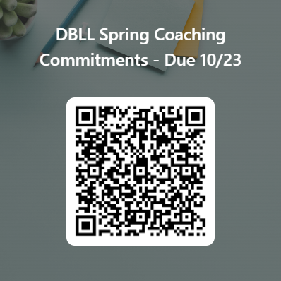
- Do you offer softball?
Yes, we do! In the past we have not had enough players to roster a full team. Please let us know if your player is interested.
- What equipment will my player need for the season?

- Bat
  - Baseball bats must meet the USABat Standard for Tee Ball, Minor, and Major Divisions
  - Baseball must meet the USABat Standard or BBCOR for Intermediate, Junior, and Senior
- Batting Helmet
- Ball glove
- Batting gloves (if desired)
- Rubber-soled cleats (for Major Division and below)
- Backpack or equipment bag (if desired)

- Are there any grants I can apply for if I need some financial assistance with the registration fee?

Yes, check out the T-Mobile Little League® Call Up Grant Program:

T-Mobile Little League® Call Up Grant Program - Little League

